**1:BIT STUFFING**

def receiver(frame):

    msg = ''.join(str(frame[i]) for i in range(8, len(frame)-8))

    msg = msg.replace('111110', '11111')

    print("Received message is: ", msg)

def sender():

    data = input("Enter the data bits: ")

    frame = '01111110' + data.replace('11111', '111110') + '01111110'

    print("Length of frame sent: ", len(frame))

    print("Frame sent: ", frame)

    receiver(list(map(int, frame)))

sender()

**2: FRAME COUNT**

def sender():

    frames = [input(f"Enter the frame {i+1}: ")

for i in range(int(input("Enter the number of frames: ")))]

    return frames

def receiver():

    frames = sender()

    print("Received frames:")

    for frame in frames:

        frame_size = len(frame.encode())

        print(f"Frame: {frame}, Size: {frame_size} bytes")

receiver()

**3:DISTANCE VECTOR**

n = int(input("Enter the number of nodes: "))

costmat = [list(map(int, input(f"Enter the cost matrix for node {i+1}: ").split())) for i in range(n)]

via = [[j for j in range(n)] for i in range(n)]

for k in range(n):

    for i in range(n):

        for j in range(n):

            if costmat[i][j] > costmat[i][k] + costmat[k][j]:

                costmat[i][j] = costmat[i][k] + costmat[k][j]

                via[i][j] = k

for i in range(n):

    print("\nFor router:", i+1)

    for j in range(n):

        print("\tnode:", j+1, "via:", via[i][j]+1, "Distance:", costmat[i][j])

**4:LEAKY BUCKET**

import random

import time

def flow(pktsize, output):

    buketsize = 512

    if pktsize > buketsize:

        print("Bucket overflow")

    else:

        time.sleep(1)

        while pktsize > output:

            print(str(output) + " bytes outflow")

            pktsize = pktsize - output

        if pktsize > 0:

            print(str(pktsize) + " bytes outflow")

def main():

    output = int(input("Enter output rate: "))

    n = int(input("Enter number of packets: "))

    for i in range(1, n+1):

        pktsize = random.randint(0, 999)

        print("Packet No: " + str(i) + " packetsize = " + str(pktsize))

        flow(pktsize, output)

if __name__ == "__main__":

    main()

**5:CRC**

#include <stdio.h>

#include <string.h>

int main() {

    char data[100];

    char divisor[30];

    char temp[30];

    char rem[30];

    char zero[30];

    int keylen, msglen, ch, f;

    printf("Enter Data: ");

    scanf("%s", data);

    printf("Enter divisor: ");

    scanf("%s", divisor);

    keylen = strlen(divisor);

    msglen = strlen(data);

    for (int i = 0; i < keylen - 1; i++)

        data[msglen + i] = '0';

    printf("\ndata after appending zeros: %s\n", data);

    for (int i = 0; i < keylen; i++)

        zero[i] = '0';

    for (int i = 0; i < keylen; i++)

        temp[i] = data[i];

    for (int i = 0; i < msglen; i++) {

        if (temp[0] == '0')

            strcpy(rem, zero);

        else

            strcpy(rem, divisor);

        for (int j = 0; j < keylen - 1; j++)

            rem[j] = (temp[j + 1] == rem[j + 1]) ? '0' : '1';

        rem[keylen - 1] = data[i + keylen];

        strcpy(temp, rem);

    }

    strcat(data, rem);

    printf("\nRemainder is %s\n", rem);

    printf("\ndata after appending remainder: %s\n", data);

    printf("\nDo you want to introduce an error (Y/N)? ");

    getchar(); // Consume the newline character

    ch = getchar();

    if (ch == 'Y' || ch == 'y')

        data[msglen / 2] = (data[msglen / 2] == '0') ? '1' : '0';

    for (int i = 0; i < keylen; i++)

        temp[i] = data[i];

    for (int i = 0; i < msglen; i++) {

        if (temp[0] == '0')

            strcpy(rem, zero);

        else

            strcpy(rem, divisor);

        for (int j = 0; j < keylen - 1; j++)

            rem[j] = (temp[j + 1] == rem[j + 1]) ? '0' : '1';

        rem[keylen - 1] = data[i + keylen];

        strcpy(temp, rem);

    }

    printf("\nData obtained: %s\n", data);

    printf("Remainder is %s\n", rem);

    f = 1;

    for (int i = 0; i < keylen - 1; i++) {

        if (rem[i] != '0') {

            f = 0;

            break;

        }

    }

    if (f == 1) {

        printf("No Error Occurred. Final data is: ");

        for (int i = 0; i < msglen; i++)

            printf("%c", data[i]);

        printf("\n");

    } else {

        printf("Error Occurred\n");

    }

    return 0;

}

**6: TCP:**

*SERVER.PY*

import socket, os

HOST = "localhost" # The server's hostname or IP address

PORT = 5000 # The port used by the server

with socket.socket(socket.AF_INET, socket.SOCK_STREAM) as s:

 s.bind((HOST, PORT))

 s.listen(1)

 while True:

    print('\nWaiting for client connection...')

    conn, addr = s.accept()

    with conn:

        print("Connection from:", addr)

        while True:

            filename = conn.recv(1024).decode()

            if not filename:

                break

            print('Requested filename:', filename)

            if not os.path.exists(filename):

                print('Status: File not found.')

                conn.sendall(b'file not found')

            else:

                with open(filename) as file:

                    conn.sendall(file.read().encode())

                print('Status: File transmitted...')

                break

        print("Closing this connection...")

*CLIENT.PY*

import socket

HOST = "127.0.0.1" # The server's hostname or IP address

PORT = 5000 # The port used by the server

with socket.socket(socket.AF_INET, socket.SOCK_STREAM) as s:

    filename = input('Enter the filename: ')

    s.connect((HOST, PORT))

    print('Connected to ', HOST)

    s.sendall(filename.encode())

    print('Filename sent...')

    data = s.recv(1024).decode()

    if data.startswith('file not found'):

        print(f'Requested file {filename!r} not found in server {HOST!r}.')

    else:

        print(f'Receiving requested file {filename!r}...', end='\n')

        with open(filename, 'w') as file:

            while True:

                file.write(data)

                if not data:

                    break

                data = s.recv(1024).decode()

        with open(filename,'r') as filer:

            print(filer.readline())

        print('done.')

    s.close()

*create a file: abc.txt in same folder as server.py and client.py*

*terminal-> split terminal*

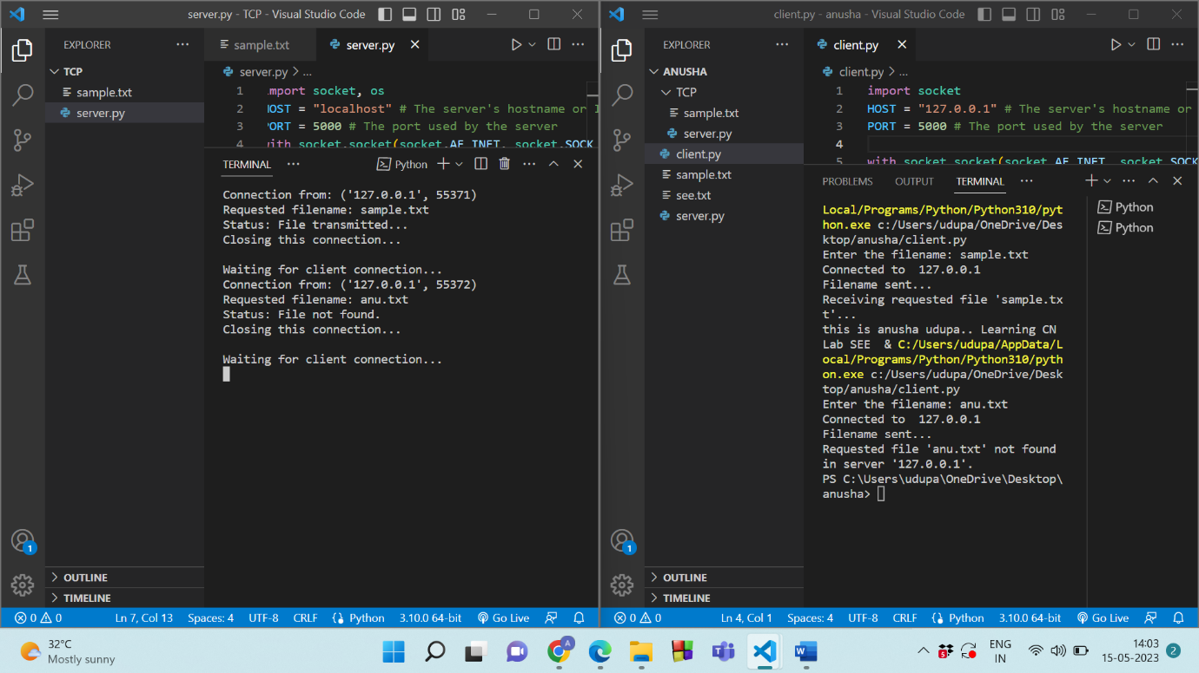

***7:UDP*** *Server*

import socket

HOST = "localhost"  # The server's hostname or IP address

PORT = 5000  # The port used by the server

with socket.socket(socket.AF_INET, socket.SOCK_DGRAM) as s:

    s.bind((HOST, PORT))

    print('Server listening...')

    while True:

        data, addr = s.recvfrom(1024)

        filename = data.decode()

        print('Requested filename:', filename)

        try:

            with open(filename, 'r') as file:

                file_data = file.read()

                s.sendto(file_data.encode(), addr)

                print('Status: File transmitted')

        except FileNotFoundError:

            s.sendto(b'file not found', addr)

            print('Status: File not found')

*client*

import socket

HOST = "127.0.0.1"  # The server's hostname or IP address

PORT = 5000  # The port used by the server

with socket.socket(socket.AF_INET, socket.SOCK_DGRAM) as s:

    filename = input('Enter the filename: ')

    s.sendto(filename.encode(), (HOST, PORT))

    print('Filename sent...')

    while True:

        data, addr = s.recvfrom(1024)

        if data.startswith(b'file not found'):

            print(f'Requested file {filename!r} not found in server {HOST!r}.')

            break

        else:

            with open(filename, 'w') as file:

                file.write(data.decode())

            print(f'Receiving requested file {filename!r}...')

            break

    with open(filename, 'r') as file:

        print(file.readline())

    print('done.')

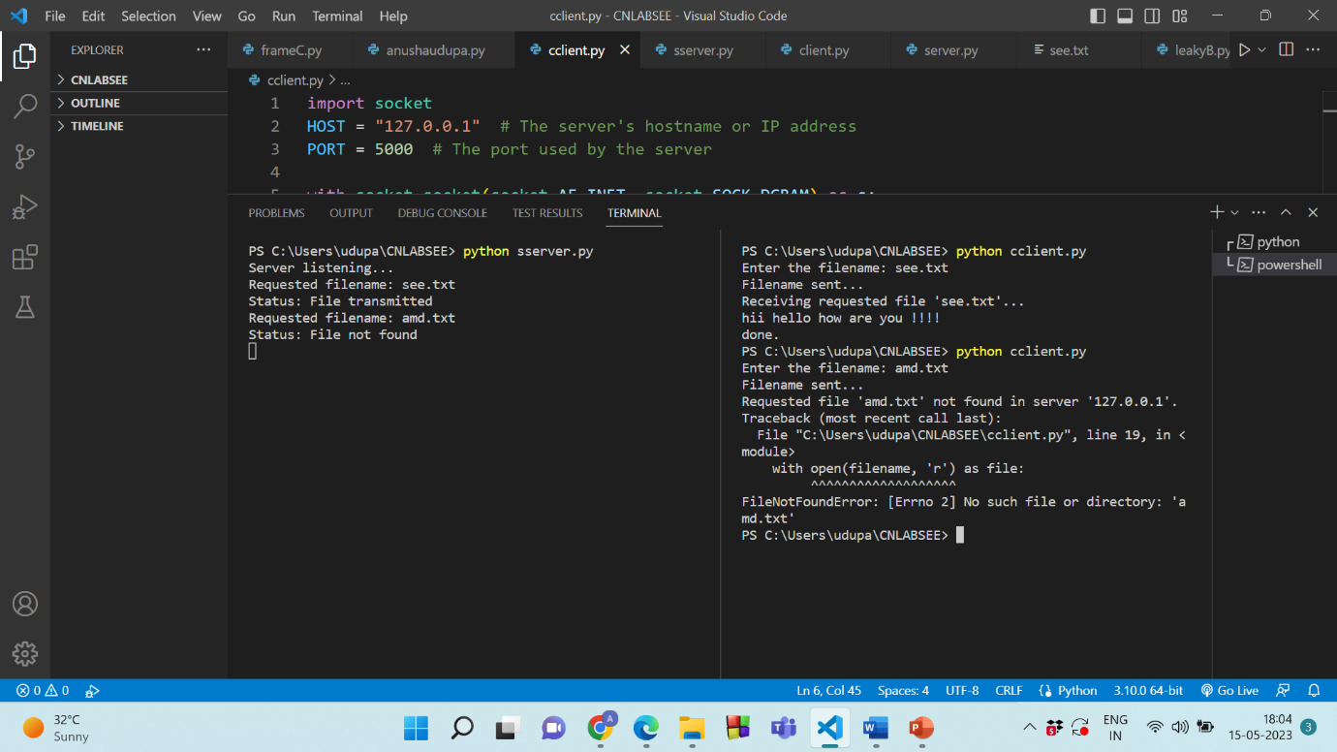

**PROGRAM 1:**

**Simulate peer-to-peer communication between a client and a server using Point-to-Point protocol. Apply NetAnim software to demonstrate the scenario graphically. Analyze packet parameters by creating trace file usingAscii trace metrics.**

/* -*- Mode:C++; c-file-style:"gnu"; indent-tabs-mode:nil; -*- */

/*

* This program is free software; you can redistribute it and/or modify

* it under the terms of the GNU General Public License version 2 as

* published by the Free Software Foundation;

*

* This program is distributed in the hope that it will be useful,

* but WITHOUT ANY WARRANTY; without even the implied warranty of

* MERCHANTABILITY or FITNESS FOR A PARTICULAR PURPOSE. See the

* GNU General Public License for more details.

*

* You should have received a copy of the GNU General Public License

* along with this program; if not, write to the Free Software

* Foundation, Inc., 59 Temple Place, Suite 330, Boston, MA 02111-1307 USA

*/

#include "ns3/core-module.h"

#include "ns3/network-module.h"

#include "ns3/internet-module.h"

#include "ns3/point-to-point-module.h"

#include "ns3/applications-module.h"

#include "ns3/netanim-module.h"

// Default Network Topology

//

// 10.1.1.0

// n0 -------------- n1

// point-to-point

//

using namespace ns3;

NS_LOG_COMPONENT_DEFINE ("FirstScriptExample");

int

main (int argc, char *argv[])

{

CommandLine cmd (__FILE__);

cmd.Parse (argc, argv);

Time::SetResolution (Time::NS);

LogComponentEnable ("UdpEchoClientApplication", LOG_LEVEL_INFO);

LogComponentEnable ("UdpEchoServerApplication", LOG_LEVEL_INFO);

std::string animFile="first.xml";

NodeContainer nodes;

nodes.Create (2);

PointToPointHelper pointToPoint;

pointToPoint.SetDeviceAttribute ("DataRate", StringValue ("5Mbps"));

pointToPoint.SetChannelAttribute ("Delay", StringValue ("2ms"));

NetDeviceContainer devices;

devices = pointToPoint.Install (nodes);

InternetStackHelper stack;

stack.Install (nodes);

Ipv4AddressHelper address;

address.SetBase ("10.1.1.0", "255.255.255.0");

Ipv4InterfaceContainer interfaces = address.Assign (devices);

UdpEchoServerHelper echoServer (9);

ApplicationContainer serverApps = echoServer.Install (nodes.Get (1));

serverApps.Start (Seconds (1.0));

serverApps.Stop (Seconds (10.0));

AnimationInterface anim(animFile);

anim.SetConstantPosition(nodes.Get(0),1.0,2.0);

anim.SetConstantPosition(nodes.Get(1),45.0,60.0);

AsciiTraceHelper ascii;

pointToPoint.EnableAsciiAll(ascii.CreateFileStream("first.tr"));

UdpEchoClientHelper echoClient (interfaces.GetAddress (1), 9);

echoClient.SetAttribute ("MaxPackets", UintegerValue (1));

echoClient.SetAttribute ("Interval", TimeValue (Seconds (1.0)));

echoClient.SetAttribute ("PacketSize", UintegerValue (1024));

ApplicationContainer clientApps = echoClient.Install (nodes.Get (0));

clientApps.Start (Seconds (2.0));

clientApps.Stop (Seconds (10.0));

Simulator::Run ();

Simulator::Destroy ();

return 0;

}

**PROGRAM 2:**

**Simulate to implement a bus topology using Point-to-Point protocol betweena client and a LAN with 4 nodes. The LAN use CSMA during packet transmission. Apply NetAnim software to demonstrate the scenario graphically. Analyze packet parameters by creating trace file using Ascii trace metrics.**

/* -*- Mode:C++; c-file-style:"gnu"; indent-tabs-mode:nil; -*- */

/*

* This program is free software; you can redistribute it and/or modify

* it under the terms of the GNU General Public License version 2 as

* published by the Free Software Foundation;

*

* This program is distributed in the hope that it will be useful,

* but WITHOUT ANY WARRANTY; without even the implied warranty of

* MERCHANTABILITY or FITNESS FOR A PARTICULAR PURPOSE. See the

* GNU General Public License for more details.

*

* You should have received a copy of the GNU General Public License

* along with this program; if not, write to the Free Software

* Foundation, Inc., 59 Temple Place, Suite 330, Boston, MA 02111-1307 USA

*/

#include "ns3/core-module.h"

#include "ns3/network-module.h"

#include "ns3/csma-module.h"

#include "ns3/internet-module.h"

#include "ns3/point-to-point-module.h"

#include "ns3/applications-module.h"

#include "ns3/ipv4-global-routing-helper.h"

#include "ns3/netanim-module.h"

// Default Network Topology

//

// 10.1.1.0

// n0 -------------- n1 n2 n3 n4

// point-to-point | | | |

// ================

// LAN 10.1.2.0

using namespace ns3;

NS_LOG_COMPONENT_DEFINE ("SecondScriptExample");

int

main (int argc, char *argv[])

{

bool verbose = true;

uint32_t nCsma = 3;

CommandLine cmd (__FILE__);

cmd.AddValue ("nCsma", "Number of \"extra\" CSMA nodes/devices", nCsma);

cmd.AddValue ("verbose", "Tell echo applications to log if true", verbose);

cmd.Parse (argc,argv);

if (verbose)

{

LogComponentEnable ("UdpEchoClientApplication", LOG_LEVEL_INFO);

LogComponentEnable ("UdpEchoServerApplication", LOG_LEVEL_INFO);

}

std::string animFile="second.xml";

nCsma = nCsma == 0 ? 1 : nCsma;

NodeContainer p2pNodes;

p2pNodes.Create (2);

NodeContainer csmaNodes;

csmaNodes.Add (p2pNodes.Get (1));

csmaNodes.Create (nCsma);

PointToPointHelper pointToPoint;

pointToPoint.SetDeviceAttribute ("DataRate", StringValue ("5Mbps"));

pointToPoint.SetChannelAttribute ("Delay", StringValue ("2ms"));

NetDeviceContainer p2pDevices;

p2pDevices = pointToPoint.Install (p2pNodes);

CsmaHelper csma;

csma.SetChannelAttribute ("DataRate", StringValue ("100Mbps"));

csma.SetChannelAttribute ("Delay", TimeValue (NanoSeconds (6560)));

NetDeviceContainer csmaDevices;

csmaDevices = csma.Install (csmaNodes);

InternetStackHelper stack;

stack.Install (p2pNodes.Get (0));

stack.Install (csmaNodes);

Ipv4AddressHelper address;

address.SetBase ("10.1.1.0", "255.255.255.0");

Ipv4InterfaceContainer p2pInterfaces;

p2pInterfaces = address.Assign (p2pDevices);

address.SetBase ("10.1.2.0", "255.255.255.0");

Ipv4InterfaceContainer csmaInterfaces;

csmaInterfaces = address.Assign (csmaDevices);

UdpEchoServerHelper echoServer (9);

ApplicationContainer serverApps = echoServer.Install (csmaNodes.Get (nCsma));

serverApps.Start (Seconds (1.0));

serverApps.Stop (Seconds (10.0));

UdpEchoClientHelper echoClient (csmaInterfaces.GetAddress (nCsma), 9);

echoClient.SetAttribute ("MaxPackets", UintegerValue (1));

echoClient.SetAttribute ("Interval", TimeValue (Seconds (1.0)));

echoClient.SetAttribute ("PacketSize", UintegerValue (1024));

ApplicationContainer clientApps = echoClient.Install (p2pNodes.Get (0));

clientApps.Start (Seconds (2.0));

clientApps.Stop (Seconds (10.0));

Ipv4GlobalRoutingHelper::PopulateRoutingTables ();

//pointToPoint.EnablePcapAll ("second");

//csma.EnablePcap ("second", csmaDevices.Get (1), true);

AnimationInterface anim(animFile);

anim.SetConstantPosition(p2pNodes.Get(0),1.0,2.0);

anim.SetConstantPosition(p2pNodes.Get(1),45.0,60.0);

anim.SetConstantPosition(csmaNodes.Get(1),55.0,60.0);

anim.SetConstantPosition(csmaNodes.Get(2),65.0,60.0);

anim.SetConstantPosition(csmaNodes.Get(3),75.0,60.0);

AsciiTraceHelper ascii;

pointToPoint.EnableAsciiAll(ascii.CreateFileStream("p2p.tr"));

csma.EnableAsciiAll(ascii.CreateFileStream("csma.tr"));

Simulator::Run ();

Simulator::Destroy ();

return 0;

}

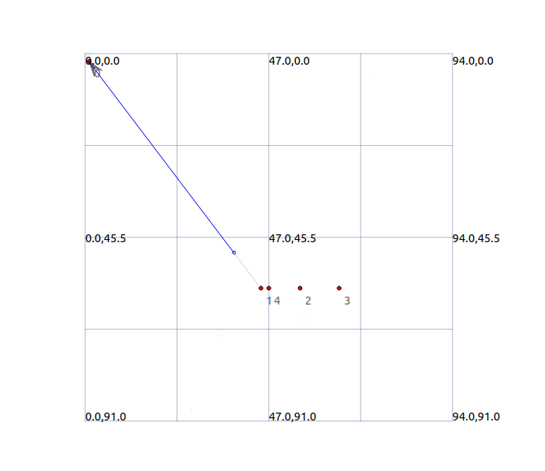

**PROGRAM 3:**

**Simulate peer-to-peer communication between a client and a server using CSMA protocol. Apply NetAnim software to demonstrate the scenario graphically. Analyze packet parameters by creating trace file using Ascii trace metrics.**

/* -*- Mode:C++; c-file-style:"gnu"; indent-tabs-mode:nil; -*- */

/*

* This program is free software; you can redistribute it and/or modify

* it under the terms of the GNU General Public License version 2 as

* published by the Free Software Foundation;

*

* This program is distributed in the hope that it will be useful,

* but WITHOUT ANY WARRANTY; without even the implied warranty of

* MERCHANTABILITY or FITNESS FOR A PARTICULAR PURPOSE. See the

* GNU General Public License for more details.

*

* You should have received a copy of the GNU General Public License

* along with this program; if not, write to the Free Software

* Foundation, Inc., 59 Temple Place, Suite 330, Boston, MA 02111-1307 USA

*/

#include "ns3/core-module.h"

#include "ns3/network-module.h"

#include "ns3/csma-module.h"

#include "ns3/internet-module.h"

#include "ns3/point-to-point-module.h"

#include "ns3/applications-module.h"

#include "ns3/ipv4-global-routing-helper.h"

#include "ns3/netanim-module.h"

// Default Network Topology

//

// 10.1.1.0

// n0 -------------- n1 n2 n3 n4

// point-to-point | | | |

// ================

// LAN 10.1.2.0

using namespace ns3;

NS_LOG_COMPONENT_DEFINE ("SecondScriptExample");

int

main (int argc, char *argv[])

{

bool verbose = true;

uint32_t nCsma = 4;

CommandLine cmd (__FILE__);

cmd.AddValue ("nCsma", "Number of \"extra\" CSMA nodes/devices", nCsma);

cmd.AddValue ("verbose", "Tell echo applications to log if true", verbose);

cmd.Parse (argc,argv);

if (verbose)

{

LogComponentEnable ("UdpEchoClientApplication", LOG_LEVEL_INFO);

LogComponentEnable ("UdpEchoServerApplication", LOG_LEVEL_INFO);

}

std::string animFile="third.xml";

nCsma = nCsma == 0 ? 1 : nCsma;

//NodeContainer p2pNodes;

//p2pNodes.Create (2);

NodeContainer csmaNodes;

csmaNodes.Create (nCsma);

//PointToPointHelper pointToPoint;

//pointToPoint.SetDeviceAttribute ("DataRate", StringValue ("5Mbps"));

//pointToPoint.SetChannelAttribute ("Delay", StringValue ("2ms"));

//NetDeviceContainer p2pDevices;

// p2pDevices = pointToPoint.Install (p2pNodes);

CsmaHelper csma;

csma.SetChannelAttribute ("DataRate", StringValue ("100Mbps"));

csma.SetChannelAttribute ("Delay", TimeValue (NanoSeconds (6560)));

NetDeviceContainer csmaDevices;

csmaDevices = csma.Install (csmaNodes);

InternetStackHelper stack;

//stack.Install (p2pNodes.Get (0));

stack.Install (csmaNodes);

Ipv4AddressHelper address;

//address.SetBase ("10.1.1.0", "255.255.255.0");

//Ipv4InterfaceContainer p2pInterfaces;

//p2pInterfaces = address.Assign (p2pDevices);

address.SetBase ("10.1.2.0", "255.255.255.0");

Ipv4InterfaceContainer csmaInterfaces;

csmaInterfaces = address.Assign (csmaDevices);

UdpEchoServerHelper echoServer (9);

ApplicationContainer serverApps = echoServer.Install (csmaNodes.Get (3));

serverApps.Start (Seconds (1.0));

serverApps.Stop (Seconds (10.0));

UdpEchoClientHelper echoClient (csmaInterfaces.GetAddress (3), 9);

echoClient.SetAttribute ("MaxPackets", UintegerValue (1));

echoClient.SetAttribute ("Interval", TimeValue (Seconds (1.0)));

echoClient.SetAttribute ("PacketSize", UintegerValue (1024));

ApplicationContainer clientApps = echoClient.Install (csmaNodes.Get (0));

clientApps.Start (Seconds (2.0));

clientApps.Stop (Seconds (10.0));

//Ipv4GlobalRoutingHelper::PopulateRoutingTables ();

//pointToPoint.EnablePcapAll ("second");

//csma.EnablePcap ("second", csmaDevices.Get (1), true);

AnimationInterface anim(animFile);

//anim.SetConstantPosition(p2pNodes.Get(0),1.0,2.0);

anim.SetConstantPosition(csmaNodes.Get(0),45.0,60.0);

anim.SetConstantPosition(csmaNodes.Get(1),55.0,60.0);

anim.SetConstantPosition(csmaNodes.Get(2),65.0,60.0);

anim.SetConstantPosition(csmaNodes.Get(3),75.0,60.0);

AsciiTraceHelper ascii;

//pointToPoint.EnableAsciiAll(ascii.CreateFileStream("p2p.tr"));

csma.EnableAsciiAll(ascii.CreateFileStream("csma.tr"));

Simulator::Run ();

Simulator::Destroy ();

return 0;

}

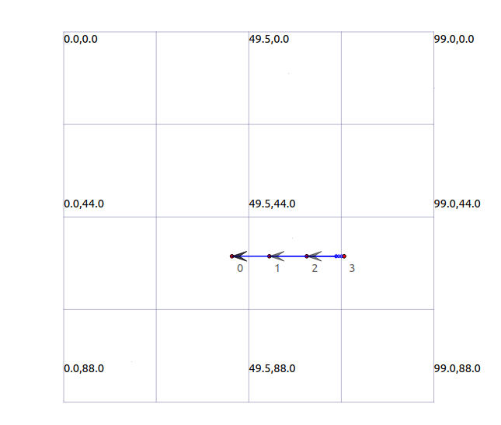

*4. fifth.cc (changes to second.cc)*

*#include "ns3/core-module.h"*

*#include "ns3/network-module.h"*

*#include "ns3/csma-module.h"*

*#include "ns3/internet-module.h"*

*#include "ns3/internet-apps-module.h"*

*#include "ns3/point-to-point-module.h"*

*#include "ns3/applications-module.h"*

*#include "ns3/ipv4-global-routing-helper.h"*

*#include "ns3/netanim-module.h"*

*// Default Network Topology*

*//*

*// 10.1.1.0*

*// n0 -------------- n1 n2 n3 n4*

*// point-to-point | | | |*

*// ================*

*// LAN 10.1.2.0*

*using namespace ns3;*

*NS_LOG_COMPONENT_DEFINE ("SecondScriptExample");*

*int*

*main (int argc, char *argv[])*

*{*

*bool verbose = true;*

*uint32_t nCsma = 3;*

*CommandLine cmd (__FILE__);*

*cmd.AddValue ("nCsma", "Number of \"extra\" CSMA nodes/devices", nCsma);*

*cmd.AddValue ("verbose", "Tell echo applications to log if true", verbose);*

*cmd.Parse (argc,argv);*

*if (verbose)*

*{*

*LogComponentEnable ("UdpEchoClientApplication", LOG_LEVEL_INFO);*

*LogComponentEnable ("UdpEchoServerApplication", LOG_LEVEL_INFO);*

*}*

*std::string animFile = "fifth.xml";*

*nCsma = nCsma == 0 ? 1 : nCsma;*

*NodeContainer p2pNodes;*

*p2pNodes.Create (2);*

*NodeContainer csmaNodes;*

*csmaNodes.Add (p2pNodes.Get (1));*

*csmaNodes.Create (nCsma);*

*PointToPointHelper pointToPoint;*

*pointToPoint.SetDeviceAttribute ("DataRate", StringValue ("5Mbps"));*

*pointToPoint.SetChannelAttribute ("Delay", StringValue ("2ms"));*

*NetDeviceContainer p2pDevices;*

*p2pDevices = pointToPoint.Install (p2pNodes);*

*CsmaHelper csma;*

*csma.SetChannelAttribute ("DataRate", StringValue ("100Mbps"));*

*csma.SetChannelAttribute ("Delay", TimeValue (NanoSeconds (6560)));*

*NetDeviceContainer csmaDevices;*

*csmaDevices = csma.Install (csmaNodes);*

*InternetStackHelper stack;*

*stack.Install (p2pNodes.Get (0));*

*stack.Install (csmaNodes);*

*Ipv4AddressHelper address;*

*address.SetBase ("10.1.1.0", "255.255.255.0");*

*Ipv4InterfaceContainer p2pInterfaces;*

*p2pInterfaces = address.Assign (p2pDevices);*

*address.SetBase ("10.1.2.0", "255.255.255.0");*

*Ipv4InterfaceContainer csmaInterfaces;*

*csmaInterfaces = address.Assign (csmaDevices);*

*UdpEchoServerHelper echoServer (9);*

*ApplicationContainer serverApps = echoServer.Install (csmaNodes.Get (nCsma));*

*serverApps.Start (Seconds (1.0));*

*serverApps.Stop (Seconds (10.0));*

*UdpEchoClientHelper echoClient (csmaInterfaces.GetAddress (nCsma), 9);*

*echoClient.SetAttribute ("MaxPackets", UintegerValue (1));*

*echoClient.SetAttribute ("Interval", TimeValue (Seconds (1.0)));*

*echoClient.SetAttribute ("PacketSize", UintegerValue (1024));*

*ApplicationContainer clientApps = echoClient.Install (p2pNodes.Get (0));*

*clientApps.Start (Seconds (2.0));*

*clientApps.Stop (Seconds (10.0));*

*Ipv4GlobalRoutingHelper::PopulateRoutingTables ();*

*pointToPoint.EnablePcapAll ("second");*

*csma.EnablePcap ("second", csmaDevices.Get (1), true);*

*V4PingHelper ping = V4PingHelper(csmaInterfaces.GetAddress(2));*

*NodeContainer pingers;*

*pingers.Add(csmaNodes.Get(0));*

*pingers.Add(csmaNodes.Get(1));*

*ApplicationContainer apps = ping.Install(pingers);*

*apps.Start(Seconds(2.0));*

*apps.Stop(Seconds(3.0));*

*csma.EnablePcapAll("csma-ping", true);*

*AnimationInterface anim(animFile);*

*anim.SetConstantPosition(csmaNodes.Get(0), 20.0, 100.0);*

*anim.SetConstantPosition(csmaNodes.Get(1), 20.0, 60.0);*

*anim.SetConstantPosition(csmaNodes.Get(2), 55.0, 30.0);*

*Simulator::Run ();*

*Simulator::Destroy ();*

*Return 0;*

*}*